Alla G. Vronskaya
Massachusetts Institute of Technology
State Institute for Art Studies, Moscow

Chernikhov, Iakov (1889-1951)
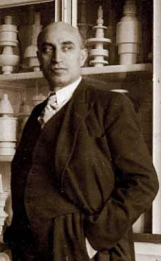

Iakov Chernikhov
http://www.icif.ru/about.htm

Iakov Georgievich Chernikhov was born in Pavlograd, Yekaterinenskav Gubernia of the Russian Empire (today Dnepropetrovskaya Oblast’, Ukraine) in an impoverished petty bourgeois Jewish family. Having demonstrated an artistic talent already in his childhood, as a teenager Chernikhov worked as an apprentice in a photography workshop and (after running away from home, where his desire to become an artist found little support) studied in Odessa Art School (Odesskoe Khudozhestvennoe Uchilishche) in 1906-14. After graduating from the School, Chernikhov entered the Academy of Arts in St. Petersburg, from which he received a diploma in architecture in 1925. Chernikhov’s training as both an artist and an architect determined his idiosyncratic approach to architectural form and his particular interest in the aspects of its representation.
Since his years in Odessa Art School, Chernikhov had been interested in drafting techniques and, in particular, in the geometric construction of ornament. Already in 1915, under the influence of modernist art movements, Chernikhov decided to create a “new ornament,” devoid of symmetry and repetitive rhythm. During the next several years, Chernikhov developed these ideas into a novel art form, “exprimatics” (from the French exprimer, to express), which expressed abstract ideas in geometric forms. In 1918-24, he supplemented exprimatics with “aristography” (from the Greek aristo, the most beautiful), which suggested a way of intensifying spatial compositions through colour. If Chernikhov’s early work was predominantly abstract, in the early 1930s he applied the fundamental premises of exprimatics and aristography to architectural drawing. Published as a series of colourfully illustrated books, these drawings merged painterly (EXPRESSIONISM, CUBISM, SUPREMATISM) and architectural (axonometry, architectural plan conventions) techniques of representation in order to create fanciful images of utopian cities, factories, machines, and abstract geometric forms and their combinations. Chernikhov’s later graphic cycles produced in the late 1930s and 1940s responded to the historicist turn in Soviet architecture, rejecting modernist graphic minimalism in favour of Piranesi-inspired, quasi-Surrealist dreamy landscapes.
Although today Chernikhov is mostly remembered as an author of utopian drawings, he led a prolific architectural practice. Between 1926 and 1941 he was involved in design and construction of several dozens of buildings, predominantly industrial (chemical and metallurgical factories) and residential ones. His best-known work is the water tower of a rope-making workshop of the Krasnyi Gvozdil’shchik (“The Red Nailer”) factory (1930-31) in Leningrad. Well-paid, Chernikhov’s architectural commissions allowed the architect to publish his drawings in colour (an exceptional fact considering the scarcity of Soviet printing resources) and even to finance his own Scientific-Research Laboratory of Architectural Forms and Methods of Graphics in Leningrad (1927-34). Moreover, throughout his career, Chernikhov remained active as a pedagogue, teaching at the Leningrad Institute of Transportation Engineers (1928-45) and several industrial and transportation higher educational institutions in Moscow.
Publications:
Iskusstvo nachertanii︠a︡ [The art of drafting]. Leningrad: Izd-vo Akademii khudozhestv, 1927.
Ornament: kompozit︠s︡ionno-klassicheskie postroenii︠a︡ [Ornament: compositional-classical designs]. Leningrad: Izd. avtora, 1930.
Osnovy sovremennoi arkhitektury: ėksperimentalʹno-issledovatelʹskie raboty [Fundamentals of modern Architecture: experimental-research works]. Leningrad : Izd. Leningradskogo ob-va arkhitektorov, 1930.
Konstruktsii arkhitekturnykh i mashinnykh form [Construction of Architectural and Machine Forms], [Leningrad] : Izd. Leningradskogo ob-va arkhitektorov, 1931.
Arkhitekturnye fantazii. 101 Kompozitsia [Architectural Fantasies. 101 Compositions], Leningrad : Izd. Leningradskogo obl. otd-ni︠i︡a Vses. obʺedinenii︠a︡ "Mezhdunarodna︠i︡a kniga", 1933.

Selected graphic cycles:
Ornament, 1915-27
Exprimatics, 1915-1920s
Aristography, 1914-27
Architecture of Industry, 1932-36
Architectural Fairy Tales, 1927-34
Architectural Ensembles, 1937-43
The Palaces of Communism (1934-41)
The Pantheons of the Great Patriotic War (1942-45)

Selected Works:
Water tower, Krasnyi Gvozdil’shchik [“The Red Nailer”] factory (1930-31, Leningrad).
Rope-making and steel-wire workshops, Krasnyi Gvozdil’shchik factory, (1930-31, Leningrad).
Neva chemical factory (1930-34, Leningrad).
Perm’ bichromate factory (1934, Perm’).

References and Further Reading
Cooke, C. (ed.) (1989) “Fantasy and Construction - Iakov Chernikhov” in Architectural Design, vol. 59, no. 7–8, London.
Olmo, C. and de Magistris, A. (1995) Jakov Černihov: documenti e riproduzioni dall'archivio di Aleksej e Dimitri Černihov. Torino: Umberto Allemandi,
Chernikhov, I. (2011) Moi tvorcheskii put’, Moscow: Russkii Avangard.

Visual Material:
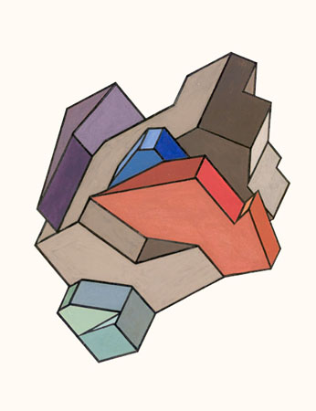
Aristography, 1914-27.
http://www.icif.ru/cyc/aristo/pages/aristo-fond-73.htm
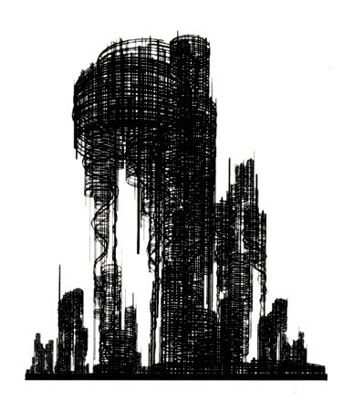
The Fundamentals of Contemporary Architecture, 1925-30.
http://www.icif.ru/cyc/oca/pages/OCA-116fond.htm

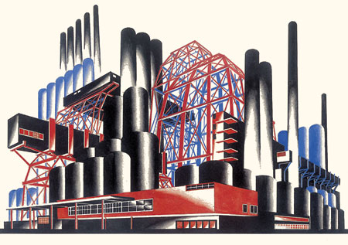
Architectural fantasies, 1925-33.
http://www.icif.ru/cyc/101/pages/32.htm

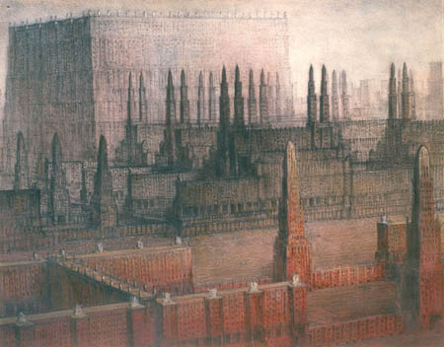
The Palaces of Communism, 1934-41
http://www.icif.ru/cyc/dvor/pages/dv-017.htm

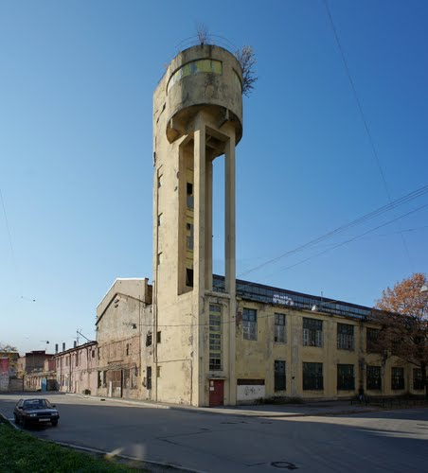
Water-tower of Krasnyi Gvozdil’shchik (“The Red Nailer”) factory (1930-31).
http://www.panoramio.com/photo/60389957

